

Southern California Edison
CS Re-Platform Project

CIM-CS-13 - Manage Inbound Telephone Call - IVR
Customer Interaction Management
Business Process Design
Version 1.8

Table of Contents
1 Business Process Overview 5
1.1 Current Pain Points for Southern California Edison 5
1.2 Responsible Parties 5
1.3 Document Control 6
1.4 Terminology 6
2 Business Process Design 8
2.1 Interactive Voice Response (IVR) Details 8
2.1.1 IVR Functions 8
2.1.1.1 Customer Authentication 8
2.1.1.2 Call Transfer 9
2.1.1.3 Credit & Collection 9
2.1.1.4 Payment options & Processing 10
2.1.1.5 Power Outage Storm & Disaster 11
2.1.1.6 Payment Extension 11
2.1.1.7 Budget Billing 12
2.1.1.8 Program Enrollment/Information Requests 12
2.1.1.9 Community Choice Aggregation (CCA) and Direct Access (DA) 14
2.1.1.10 Rates 15
2.1.2 Business Partner Contacts 15
2.1.3 Standard Multichannel OData 16
Managing Customer Details 16
2.1.3.1 Managing Utility Contracts 19
2.1.3.2 Managing Meter Reading Data 20
2.1.3.3 Viewing Bills and Consumption 20
2.1.3.4 Managing Budget Billing Plans 21
2.1.3.5 Communicating with the Utility Company 22
2.1.3.6 Managing Payments 23
2.1.3.7 Managing Outages 24
2.2 Process / Performance Improvement 25
2.3 Prerequisites and Inputs 25
2.4 General Assumptions 26
2.5 Business Process Hierarchy 26
2.7 3rd Party and SCE Legacy System Integrations 26
2.8 Data Elements 26
2.8.1 Data Entry Type 26
2.8.2 Source Systems and Data Volumes 26
2.9 Cloud for Customer (C4C) Integration 26
2.9.2 C4C Views 27
2.9.3 Activity 29
2.10 Exception Management Requirements 30
2.11 Process Risks and Mitigation 30
2.12 Key Performance Indicators 30
2.12.1 Key Metric Definition 31
3 Controls, Regulatory Rules, and Security 32
3.1 Security Considerations 33
3.2 Custom Program/Transaction Codes 33
3.3 Custom Table/Transaction Codes 33
3.4 Data Criticality and Cybersecurity Baseline Risks 33
4 Technical Considerations 35
4.1 RICEF-W Assessment 35
4.1.1 Reports 35
4.1.2 Interfaces 36
4.1.3 Conversion 42
4.1.4 Extension/Enhancements 42
4.1.5 Forms 43
4.1.6 Workflows 43
4.2 IDEX Considerations 43
4.3 Production System Cut-over Considerations 43
4.4 Other Considerations 43
5 Change Management 44
5.1 Change Impacts 44
6 Requirements 46

This page intentionally left blank

Business Process Overview
Interactive Voice Response
Interactive Voice Response (IVR) systems are typically used to service high call volumes, reduce cost and improve the customer experience. Call centers use IVR systems to identify and segment callers. The ability to identify customers allows services to be tailored according to the customer profile and allows customers to choose between automated services.
The use of IVR and voice automation enables a company to improve its customer service and lower its costs since callers' queries can be resolved without the cost of a live agent who, in turn, can be directed to deal with specific areas of the service. If the caller does not find the information they need, or requires further assistance, the call is then transferred to an agent who can deal with them directly through CTI integration. This makes for a more efficient system in which agents have more time to deal with complex interactions.

1.1 Current Pain Points for Southern California Edison
- IVR must call multiple MQ transactions to obtain the information needed about the caller’s account in order to provide the caller the appropriate options (e.g., make a payment if they are almost past due or are past due)
- IVR has a complex set of menu options that have been built over 10+ years. This program is an opportunity to reduce and simplify the IVR self-service capability and focus on the key transactions that customers want and need and to reduce the number of calls our Energy Advisors must process.

1.2 Responsible Parties
Contact | Contact Person
Southern California Edison Business Process Owner | Janet Covington
Southern California Edison Lead | Christine Evans
HCL Functional Lead | Adrianus Halim
Solution Architect | Pedro Ferreira da Costa
Front Office | Christine Evans
Subject Matter Experts | Wade Waddelow  Deborah Tillman  Christine Evans  Cari Young  Ernesto Valle  Pedro Costa
Key User Group | Customer Contact Center (CCC)  Business Customer Division (BCD)

1.3 Document Control
Version | Description of Change | Date | Author
0.1 | Creation of Initial Version | 01/12/2018 | Vasu Jasti
0.2 | BPD drafted | 01/27/2018 | Vasu Jasti
0.3 | Visio and process flow added | 02/16/2018 | Vasu Jasti
0.4 | ODATA Services added | 02/25/2018 | Vasu Jasti
1.0 | BPD updated based on feedback from team review | 03/01/2018 | Vasu Jasti
1.1 | Updated with edits from feedback review | 03/02/2018 | Vasu Jasti
1.2 | Updated with R | 03/05/2018 | Vasu Jasti
1.3 | Editing numbering | 03/06/2018 | Vasu Jasti
1.4 | Edited For Upload | 03/07/2018 | Ernesto Valle
1.5 | Edits from SharePoint documents added | 04/16/2018 | Vasu Jasti
1.6 | Added details regarding CTI integration with C4C | 05/24/2018 | Vasu Jasti
1.7 | Updated Section 4 per discussion with business | 06/13/2018 | Vasu Jasti
1.8 | Final BPD Updates | 08/15/2019 | Vipul Singh

1.4 Terminology
Term/Acronym | Definition and SAP Equivalent (if applicable)
ACW | ACW – After Call Work
ANI | Automatic Number Identification - Number of the calling phone
APSE | Accelerated (or Axon) Project Support Environment
BDEX | SAP add-on functionality to support the processing of BPEM Cases
Billing Cycle | Is a group of contracts to be billed together via date-driven or regional criteria, it controls the billing cycle and is linked to the Meter Reading Unit. SAP equivalent term is the Portion.
Billing Document | A document that outlines the charges incurred for energy consumption for a specific contract. During the process of Billing, a billing document is generated for each contract on a contract account.
BMD | Business Master Data. The customer information which includes personal details, payment terms, dunning levels, billing rates and rate categories. The business master data objects are Business Partner, Business Agreement/Contract Account and Contract.
BPD | Business Process Design (or Document)
BPEM | Business Process Exception Management
BuAg | Business Agreement. The Business Agreement in CRM is equivalent to the Contract Account in CRB
BWR | Basic Work Request. SAP equivalent is BPEM.
C4C | SAP Cloud for Customer Solution
CA | Contract Account
CAD | Caller Attached Data
Call Type | Call Type - The caller’s intent, which is based on caller input (menu options)
Channel | Data object in SAP that holds the interval data. Intervals can be kwh, price, factor, etc. SAP equivalent is Profile.
Clarification | A list of payments that could not be processed and require additional work in order to be posted.
CONN ID | CONN ID - The unique identifier for the call within Genesys
Connection Object | Link between installation and postal regional structure. Usually a building, but can also be a piece of property or other facility, such as a fountain or construction site. The connection object corresponds to the functional location in plant maintenance (PM).
CRB | SAP Customer Relationship & Billing system. This is what is being implemented with the CSRP program.
CRM | SAP Customer Relationship Management
Customer | Any entity with a relationship with SCE. This term is usually used in reference to customers (both individuals and organizations) This can include employees and third party suppliers (banks and payment partners). SAP Equivalent is Business Partner (BP)
EAM | SAP Enterprise Asset Management
ECC | SAP ERP Central Component (SAP) - The core SAP modules (FICO, WM, SD, EAM, HR). This term is commonly used to refer to the existing SAP modules implemented at SCE.
ERP | SAP Enterprise Resource Planning
IMG | SAP Implementation Guide - where configuration is performed
Level Pay Plans | SAP equivalent term is Budget Billing. Budget Billing allows customers to pay regular equal amounts over a yearly period.
PI/PO | SAP Process Integration/Process Orchestration
SCE | Southern California Edison
Summary Billing | Standard SAP functionality that enables the invoicing of multiple Contract Accounts under one Parent Contract Account (Consolidated Summary Billing). SAP equivalent is Collective Billing.
TMD | SAP Technical Master Data e.g. Connection Object, Premise and Device Location
WSDL | WSDL – Web Services Description Language

Additional terms may be found in APSE General Document # 32 CSRP Glossary

Business Process Design

2.1 Interactive Voice Response (IVR) Details
Depending on what information the caller has keyed in via the telephone keypad, the business logic will assess the caller whether a full or partial authentication is required to perform automated transaction. Some IVR menus like billing and stop service will require a caller to have full authentication so that the request can be completed automatically without having to request a transfer to a live agent. For example, the payment arrangement will require a caller to identify and confirm an account with authentication in order to be able to request for a new payment arrangement.

IVR Functions
IVR functions will be used to provide specific information to a customer and allows customer to perform various transactional processes, for their account(s) or service location(s). These functions can be divided into categories below:

Customer Authentication
Certain IVR menus will require authentication and other menus may allow the caller to remain unauthenticated while performing specific transactions. The interface I-CIM-CS-13 - User Authentication has been identified to authenticate the caller using pre-defined validation criteria as defined below:
To authenticate a caller, IVR will initially use the ANI number to search for a Business Partner (BP) in S/4HANA. If the caller could not be identified, based on the pre-defined customer search criteria (single phone number match), IVR will then prompt the caller to enter the phone number or Contract Account (CA) number or Contract number or Installation number via telephone keypad. The caller could also use the CSS Customer Account or Service Account number that was migrated when the new SAP accounts were created. If the caller is still not found, by the ANI or phone number and Street number subsequently, the caller will be prompted to enter the Contract number. If the caller is still not authenticated, the call will then be routed to the CCC agent. Details regarding the User Authentication/Account Access process is specified in section 2.6.1.
When a customer is accessing utilizing the ANI or phone number they must enter their street numbers for verification. If a commercial customer inputs a phone number or their ANI is used, and the street number match is found they are still required to enter the Contract Account or Contract number to prevent fraud from occurring on commercial accounts. The Contract number is utilized for accessing accounts where a service order needs to be issued at that level and not at the Contract Account (since multiple Contracts can be under one Contract Account) level such as rate changes, CARE/FERA recertification, etc.
The caller will also have the ability to enter their CSS account numbers (e.g., Customer Account, Service Account or Installed Service number) to identify their SAP account.
To identify why a customer may be calling, SAP will pass relevant account details to the IVR based on the callers ANI. This would include information such as if the customer is in an overdue/final call/disconnect status, has pending extension, they are affected by an emergency or maintenance outage, they were recently send notification about a program or service (will be defaulted on to a rate or program, etc.), it is time renew, recertify or provide eligibility for a product or program (Med Baseline/Care/FERA, etc.). By providing this information, the IVR will be able to offer the customer relevant options and streamlined customer experience.
Once the user is authenticated, the below customer data is sent to IVR from S/4 HANA:
- Contract Account Number
- Current Balance
- Last Payment
- Next Bill Due Date
- Other

Call Transfer

Based on the IVR business process, a caller that could not pass user authentication will be transferred to a live agent.
In addition, any IVR process will that will require CCC agent intervention will also utilize the call transfer functionality.
Failed process requests would be routed to the CCC agent and not create a BPEM. An example of a failed process request could be failure to create a Payment Plan for the caller. The transfers of call to the agent is don’t via CTI integration and is in scope of IVR changes.

Credit & Collection
Anything related to payment information and payment method. This requires a caller to be authenticated.
- Retrieve Current account balance(s) (OData: AccountBalance, reference BPD CIM-CS-10 - Manage Customer Self-Service for interface I-CIM-CS-10 - Self Service - Billing,Payment/Enquiry hist)
- Bill amounts and due dates (OData: AccountBalance, Invoice)
- Debits and credits since the last statement (OData: ContractAccountBalance)
- Recent payment applied (OData: PaymentDocument, PaymentDocumentItem)
- Payment verification & pending payments not applied (OData: PaymentDocument, PaymentDocumentItem)
- Bill Types (deposit vs energy)
- Deposit Details (date paid, expected return date, interest earned, etc)
- Next scheduled billing date
- Rate Status – e.g., CARE or FERA participation
- Account status – Active or Inactive and if assigned to credit bureau and bureau details including phone number or some unique identifier
- Remote Service Switch Integration to identify service status, if meter has RSS enabled and meter is communicating remotely
- Ability to provide NEM accounts with billing details and summary information
- Payment Program and Program identification to offer customer relevant bill payment an program options (Direct Pay, Pay By Phone, Online Billing, Chose Bill Due Date, Cash Only, Budget Billing, and rate (residential and commercial) for Credit Card payment availability and routing purposes)
- Request for duplicate bill: an authorized caller may request a duplicate bill to be sent to the Contract Account billing address or via email. To process the request, a BPEM to OLS is generated from Interface I-CIM-CS-13 - IVR Create BPEM.
- Manage auto pay settings (OData: BankAccount, reference BPD PY-FI-09 - Receive Payments - Manage Incoming Payments for interface I-PY-FI-09 - Eligibility and Enroll Customer from SCE.COM/IVR into Direct Pay)
- Cancel auto pay (OData: BankAccount, reference BPD PY-FI-09 - Receive Payments - Manage Incoming Payments for interface I-PY-FI-09 – Eligibility, Enroll and Remove Customer from SCE.COM/IVR into Direct Pay)
- Change paperless billing settings (OData: BankAccount, I-CIM-CS-13 - E-Bill Enrollment/Un-enrol)
- Edit payment method (OData: PaymentMethod, I-CIM-CS-13 - Self Service -Manage Payment method)
- Add payment method (OData: PaymentMethod, I-CIM-CS-13 - Self Service -Manage Payment method)

Payment options & Processing

Anything related to payments. This requires a caller to be authenticated except for Authorized Payment Agent information retrieval.
- One-Time (QuickCheck) payment (I-CIM-CS-13 - Pay by Phone)
- One-Time (QuickCheck) Inquiry (I-CIM-CS-13 - Pay by Phone)
- Sign up for Direct Payment (OData: BankAccount, reference BPD PY-FI-09 - Receive Payments - Manage Incoming Payments for interface I-PY-FI-09 - Eligibility and Enroll Customer from SCE.COM/IVR into Direct Pay)
- Update Direct Payment: (OData: BankAccount, reference BPD PY-FI-09 - Receive Payments - Manage Incoming Payments for interface I-PY-FI-09 - Eligibility and Enroll Customer from SCE.COM/IVR into Direct Pay)
- Remove Direct Payment
- Direct Payment status and pending enrollment status
- Pay By Phone Enrollment (I-CIM-CS-13 - Pay by Phone
- Pay By Phone Update (I-CIM-CS-13 - Pay by Phone)
- Pay By Phone Removal (I-CIM-CS-13 - Pay by Phone)
- Pay By Phone status and pending enrollment status
- Pay By Phone payment which is currently the same as QuickCheck
- Ability to provide Contract Account number to caller if account was accessed by ANI/phone number with street numbers (for payment and an APA)
- Authorized Payment Agent information (User authentication not required). (E-PY-FI-09 - Store APA details in SAP) ability to find nearest APA locations based on customers account (if accessed/identified) or zip code entered by customer
- Ability to allow user to provide the amount for their payment (full account balance, past due balance or other amount customer wants to pay including under payment and over payment based on credit rules)
- Provide stored bank information to IVR so caller can utilize it without reentering it (Pay by Phone information is currently stored in IVR SQL table)
- Provide routing and account number validation to identify incorrect entries before being submitted for payment or enrollment into payment programs
- Stop collection activities and reconnect service when need if sufficient payment is made

Power Outage Storm & Disaster
- Real time Power outage reporting. (User authentication is required) (reference BPD DF-WM-02 - Handle Field Orders - Manage Field Orders for interface I-DF-WM-02 - SAP to OMS)
  - An outage reported in IVR will send a request to S4/HANA to create a SAP Notification. The Notification will be sent to OMS to be captured as an outage.
- Real time Power outage status/Pending Trouble Order. (reference BPD CIM-CS-10 - Manage Customer Self-Service for interface I-CIM-CS-10 - Outage Details)
- Customizable Storm & Disaster Messaging (Readily available customized recordings for extreme conditions and non-traditional outage and emergency response). (reference BPD CIM-CS-10 - Manage Customer Self-Service for interface I-CIM-CS-10 - Outage Details) such as customer relief stations and shelters and pertinent information
- Rotating Outage Group Number: (reference BPD CIM-CS-10 - Manage Customer Self-Service for interface I-CIM-CS-10 - Outage Details)
- Outage Update: (reference BPD CIM-CS-10 - Manage Customer Self-Service for interface I-CIM-CS-10 - Outage Details) ability to access via zip code, OAN, circuit, district, Rotating Outage Group #, Trouble Order number for current, future and past outages
- Ability to know next Rotating Outage Groups that will be affected
- Ability to report part lights outage when customer is not affected by an SDP event
- Ability to enroll BPs in Outage Notifications for trouble order updates, maintenance outages, repair outages and rotating outages
- Ability to know if the account identified is impacted by an active or scheduled maintenance outage, repair outage, rotating outage or SDP event

Payment Extension
This requires a caller to be fully authenticated. Payment Extension, Payment Arrangements and Final Call four day extensions eligibility based on credit rules.
- Single Payment Extension (OData: PaymentPlan, I-CC-FI-08 - Create Installment Plan via IVR)
- Past Due Payment Extension (OData: PaymentPlan, I-CC-FI-08 - Create Installment Plan via IVR)
- Two Payment Arrangement (OData: PaymentPlan, I-CC-FI-08 - Create Installment Plan via IVR)
- Three Payment Arrangement (OData: PaymentPlan, I-CC-FI-08 - Create Installment Plan via IVR)
- Final Call four day extensions (OData: PaymentPlan, I-CC-FI-08 - Create Installment Plan via IVR)
- Monthly Payment Arrangement (OData: PaymentPlan, I-CC-FI-08 - Create Installment Plan via IVR)
- Bi Weekly Payment Arrangement (OData: PaymentPlan, I-CC-FI-08 - Create Installment Plan via IVR)
- Arrears extension (OData: PaymentPlan, I-CC-FI-08 - Create Installment Plan via IVR)
- Ability to issue a HEAP Extension/Payment Arrangement
- Ability to know if the account has a HEAP pledge either pending or in the past
- Confirmation Number for transaction(s) issued not just extensions

Budget Billing
This requires a caller to be fully authenticated except for general program information retrieval.
- Program enrollment (OData: BudgetBillingPlan, reference BPD CIM-CS-10 - Manage Customer Self-Service for interface CIM-CS-10 - Self Service - Create/Cancel level pay Plan)
- Program removal (OData: BudgetBillingPlan, reference BPD CIM-CS-10 - Manage Customer Self-Service for interface CIM-CS-10 - Self Service - Create/Cancel level pay Plan)
- Year to date detailed plan summary (settlement) (OData: BudgetBillingPlan) including billed amounts, payment amounts and current settlement balance
- Month to month summary (OData: BudgetBillingPlan)

Program Enrollment/Information Requests
Anything related to programs including program enrollment, remove and information request.
- IQP (aka CARE/FERA)
  - IQP Enrollment. (User authentication is required) (reference BPD PP-CS-02 - Program Enrollment and Delivery, De-Enrollment & Decommission Programs for interface I-PP-02 - Web Service to Enroll/De-enroll in/from CARE & FERA programs)
  - IQP Recertification. (User authentication is required) (reference BPD PP-CS-02 - Program Enrollment and Delivery, De-Enrollment & Decommission Programs for interface I-PP-02 - Web Service to Enroll/De-enroll in/from CARE & FERA programs)
  - IQP Removal. (User authentication is required) (reference BPD PP-CS-02 - Program Enrollment and Delivery, De-Enrollment & Decommission Programs for interface I-PP-02 - Web Service to Enroll/De-enroll in/from CARE & FERA programs)
  - IQP Switch - ability to switch from CARE to FERA or FERA to CARE
  - Ability to check the status of a pending IQP enrollment/recertification
  - Ability to determine if customer is eligible for which IQP program CARE/FERA (number of people in household, income yearly/monthly, currently enrolled in various assistance programs)
- Critical Care (reference BPD PP-CS-02 - Program Enrollment and Delivery, De-Enrollment & Decommission Programs for interface I-PP-02 - Web Service to Enroll/De-enroll in/from CARE & FERA programs)
- Apply for an energy audit by creating a BPEM to BCD.
- Ability to enroll and check status of enrollment in the Energy Assistance (EAP) programs
- Summer Discount Plan. (User authentication is required)
  - Enroll/Update/Remove SDP (reference BPD PP-CS-02 - Program Enrollment and Delivery, De-Enrollment & Decommission Programs for Enhancement E-PP-02 - Enroll/De-enroll in/from SDP Residential & Commercial Programs automatically and which will automatically create the required Work Order to install or change the SDP device
  - Event info. (User authentication is not required) (reference BPD PP-CS-02 - Program Enrollment and Delivery, De-Enrollment & Decommission Programs for enhancement E-PP-02 - Enroll/De-enroll in/from SDP Residential & Commercial Programs)
  - Ability to know if customer is currently affected by an SDP event and time frames when applicable
  - Ability to know if account is enrolled in SDP, the enrollment details (cycling %, override/non-override, date of enrollment) or status of pending enrollment
  - Ability to know if a SDP device is at the account location and the device capabilities

- Ability to enroll/update/remove online billing
- If the account has been identified by the IVR, the IVR will enable the caller to request an application, brochure other information to be sent to associated Contract Account mailing address via U.S. mail or to the BP’s email address. The IVR will send the request to SAP to send the document via U.S. mail or email to the BP automatically (from Interface I-CIM-CS-13 - Request Letters). Documents that can be requested include:
CODE | Type
001 | Care Application (14-338) /Language Cambodian
001 | Care Application (14-338) /Language Chinese
001 | Care Application (14-338) /Language English
001 | Care Application (14-338) /Language Korean
001 | Care Application (14-338) /Language Vietnamese
012 | DAPS Brochure
032 | Medical Baseline Application (14-539-6) /Language English
015 | Temperature Sensitive Customer Notification Service for Rotating Outages
031 | Understanding Your Electricity Bill
N/A | Letter of Credit
N/A | Guarantor Letter
N/A | Letter of Residency
N/A | Duplicate Bill
N/A | Owner Tenant Agreement (Landlord Agreement)

- If the account has been identified by the IVR, the IVR will enable the caller to request one of the below brochures to be sent to associated Contract Account mailing address via U.S. mail. Once the type has been selected by the caller within the IVR, the IVR will send a BPEM request to the EE team so the brochure can be sent to the BP manually.
CODE | Type
004 | EE Rebate Single Family /Language English
019 | EE Rebate Multi-Family /Language English
025 | EE Rebate Express Commercial Solutions /Language English
017 | EE Rebate Energy Guides /Language English
N/A | Energy Savings Program Request (aka in-home energy audit)

- If the account has not been identified by the IVR, the IVR will enable to caller to record their request within IVR. An employee will listen to the request and send the requested information to the BP via U.S. Mail or email.
Code | Type | Using C4C or Manually
017 | Energy Guides | C4C
025 | Express Efficiency | C4C
004 | HEER Complete | Manually
032 | Med Baseline App(14-539-6) | C4C
019 | Multi-Family Complete | C4C
031 | Understand Your Electric Bill | C4C
001 | Care Application (14-338) /Language Cambodian | C4C
001 | Care Application (14-338) /Language Chinese | C4C
001 | Care Application (14-338) /Language English | C4C
001 | Care Application (14-338) /Language Korean | C4C
001 | Care Application (14-338) /Language Vietnamese | C4C
001 | Care Application (14-338) /Language Cambodian | C4C
012 | DAPS Brochure | C4C
015 | Temperature Sensitive Customer Notification Service for Rotating Outages | C4C
N/A | Letter of Credit | C4C
N/A | Duplicate Bill | C4C
N/A | Owner Tenant Agreement (Landlord Agreement) | C4C

Community Choice Aggregation (CCA) and Direct Access (DA)
- CCA (IDEX) Enrollment/Un-enrollment (reference BPD CIM-CS-10 - Manage Customer Self-Service for interface I-CIM-CS-10 - CCA_Opt Out, I-CIM-CS-13 - CCA/DA Enrollment)
- CCA (IDEX) Opt Out (reference BPD CIM-CS-10 - Manage Customer Self-Service for interface I-CIM-CS-10 - CCA_Opt Out, I-CIM-CS-13 - CCA/DA Enrollment)
- CCA (IDEX) Cancel Pending Opt Out Request (reference BPD CIM-CS-10 - Manage Customer Self-Service for interface I-CIM-CS-10 - CCA_Opt Out, I-CIM-CS-13 - CCA/DA Enrollment)
- CCA Eligibility (is customer eligible for CCA)
- CCA Enrollment (is customer enrolled in CCA)
- CCA Opt Out (has customer opted out of CCA)
- CCA account final call amount (only SCE charges are disconnect-able)
- Direct Access Information (is customer enrolled in DA)

Rates
An account must be identified in the IVR to enable a caller to opt-out of a default rate or to make an optional rate changes and for it to be automatically processed by the IVR and SAP. If the account is not identified by the IVR, the IVR will enable the caller to record their request and an employee will process the request via C4C outside of the IVR.
- Residential TOU Opt Out - If a residential Contract is scheduled to be defaulted on a TOU rate, the IVR will enable the caller to opt-out of the default rate change. They may choose to stay on their current rate or choose a different rate. The rates the caller can choose from will be limited. If the caller does not hear the rate they would like to choose, they can choose to speak with an ENA.
    - If the caller chooses to opt-out of the default TOU rate, IVR will send an indicator to S/4HANA to flag the Installations default TOU opt-out and the system will not process the default rate change. This information will be visible to C4C users.
    - The default TOU opt-out is only applicable for the customer who is taking electricity service at that location. If the customer Moves Out, then the default TOU opt-out indicator will need to be end-dated with the Contract.
    - If the caller chooses a different rate, the IVR will send the rate change request to S/4HANA with via BPEM to RSO Billing.
  - Default Critical Peak Pricing (CPP) Opt Out. - If a Contract is scheduled to be defaulted on CPP, the IVR will enable the caller to opt-out of the default rate and remain on their existing rate.
    - If the caller chooses to opt-out of the default CPP rate, IVR will send an indicator to S/4HANA to flag the Installation as default CPP opt-out and the system will not process the default rate change. This information will be visible to C4C users.
    - The default CPP opt-out is only applicable for the customer who is taking electricity service at that location. If the customer Moves Out, then the default CPP opt-out indicator will need to be end-dated with the Contract.
  - IVR will enable a residential caller to make an optional rate change by selecting from a limited number of eligible rates. If the caller does not hear the rate they want, they will be able to transfer to an ENA. If the caller select one of the eligible rates, IVR will send the request to S/4HANA via BPEM to RSO billing.
  - IVR shall have the ability to know the customer’s current rate and pending rate change (rate with future start date), if applicable.

Business Partner Contacts
A BP Contact can be created automatically for each IVR function completed via the IVR or if the caller retrieves information regarding their account(s). The list of IVR functions are specified in section 2.1.1.
IVR will provide the caller a confirmation number (customer contact number) for each transaction completed in the IVR. Example of transactions include payment arrangements, payment, extension and program enrollment/update/un enrollment, recertification.

Standard Multichannel OData

Managing Customer Details
The below tables list the standard Odata services that are available. We will determine which services and types to use in the Functional Specification, as well as, modifications to these services to support IVR data needs.
OData Entity | Properties
Account | - AccountTypeID  - AccountID  - AccountTitleID  - FirstName  - LastName  - MiddleName  - SecondName  - Sex  - Name1  - Name2  - Name3  - Name4  - GroupName1  - GroupName2  - FullName
ContractAccount | - AccountAddressID  - AccountID  - AlternativePayee  - AlternativePayer  - BillToAccountAddressID  - BillToAccountID  - BudgetBillingProcedure  - ContractAccountID  - CountryID  - Description  - IncomingPaymentBankAccountID  - IncomingPaymentPaymentCardID  - IncomingPaymentMethodID  - OutgoingPaymentMethodID1  - OutgoingPaymentMethodID2  - OutgoingPaymentMethodID3  - OutgoingPaymentMethodID4  - OutgoingPaymentMethodID5  - OutgoingPaymentBankAccountID  - OutgoingPaymentPaymentCardID
AccountAddress | - AccountID  - AddressID  - AddressInfo
AccountAddressIndependentEmail | - AccountID  - SequenceNo  - Email  - HomeFlag  - StandardFlag
AccountAddressIndependentMobilePhone | - AccountID  - SequenceNo  - PhoneNo  - HomeFlag  - StandardFlag  - Extension  - CompletePhoneNo  - DefaultFlag  - CountryID  - PhoneType
AccountAddressIndependentPhone | - AccountID  - SequenceNo  - PhoneNo  - HomeFlag  - StandardFlag  - Extension  - CompletePhoneNo  - CountryID  - PhoneType
AccountAddressUsage | - AccountID  - AddressID  - AddressTypeID
AccountRelationship | - AccountID  - RelationshipID  - RelatedAccountDescription  - RelatedAccountID  - AccountRelationshipTypeID  - ValidFrom  - DifferentiationValue  - ValidTo
AccountRelationshipType | - AccountRelationshipTypeID  - Description
AccountTitle | - TitleID  - AccountTypeID  - Description
AccountType | - AccountTypeID  - Description
AddressType | - AddressTypeID  - Description
CommunicationPreference | - ContractAccountID  - CommunicationCategoryID  - CommunicationMethodID  - AccountID  - AddressID
CommunicationMethod | - CommunicationMethodID  - Description
CommunicationCategory | - CommunicationCategoryID  - Description
ContactAdditionalInfo | - ContactAdditionalInfoID  - Description
GetAllowedCommunicationMethods | - Requires CommunicationCategoryID
RequestChange | - AccountContactID  - Attribute1Name  - Attribute1Value  - Attribute2Name  - Attribute2Value
Country | - CountryID  - Name
Division | - DivisionID  - Description
Installation | - InstallationID  - DivisionID  - PremiseID
PaymentStatus | - PaymentStatusID  - Description
Premise | - PremiseID  - PremiseTypeID  - AddressInfo
PremiseType | - PremiseTypeID  - Description

Managing Utility Contracts
OData Entity | Properties
Contract | - ContractID  - Description  - ContractAccountID  - DivisionID  - PremiseID  - MoveInDate  - MoveOutDate  - ProcessingStatus
ParkedDocument | - ParkedDocumentID  - AccountID  - MoveIn  - MoveOut
ParkedDocumentInstallation | - ParkedDocumentID  - InstallationID  - DivisionID  - ProductID  - ServiceProviderID
Product | - ProductID  - Description  - LongText  - IconURL  - DivisionID  - PremiseTypeID  - PersonsMin  - PersonsMax  - ConsumptionMin  - ConsumptionMax
GetPremisesForAccount | - Requires AccountID
GetPremisesByAddress | - City  - CountryID  - HouseNo  - PostalCode  - Region  - RoomNo  - Street

Managing Meter Reading Data
OData Entity | Properties
Device | - DeviceID  - ContractID  - DivisionID  - SerialNumber
FutureMeterReading | - DeviceID  - MeterReadingReasonID  - MeterReadingCategoryID  - MeterReadingDate  - SerialNumber
MeterReadingCategory | - MeterReadingCategoryID  - Description
MeterReadingNote | - MeterReadingNoteID  - Description
MeterReadingReason | - MeterReadingReasonID  - Description
MeterReadingResult | - MeterReadingResultID  - DeviceID  - RegisterID  - ReadingResult  - ReadingDateTime  - ReadingUnit  - MeterReadingNoteID  - Consumption  - MeterReadingReasonID  - MeterReadingCategoryID  - MeterReadingStatusID  - SerialNumber  - MultipleMeterReadingReasonsFlag
MeterReadingStatus | - MeterReadingStatusID  - Description

Viewing Bills and Consumption
OData Entity | Properties
AccountBalance | - AccountID  - CurrentBalance  - TotalAmount  - NetAmount  - OpenCollectable  - OpenDebits  - OpenCredits  - Currency  - Possible Op
Invoice | - InvoiceID  - AccountID  - ContractAccountID  - AmountDue  - Currency  - DueDate  - InvoiceDate  - AmountPaid  - AmountRemaining  - InvoiceDescription  - InvoiceStatusID
InvoicePDF | - InvoiceID  - MimeType  - MediaResource
ContractAccountBalance | - ContractAccountID  - CurrentBalance  - TotalAmount  - NetAmount  - OpenCollectable  - OpenDebits  - OpenCredits  - Currency
ConsumptionPeriodType | - ConsumptionPeriodTypeID  - Description
ContractConsumptionValue | - ContractID  - ConsumptionPeriodTypeID  - StartDate  - EndDate  - BilledAmount  - Currency  - ConsumptionValue  - ConsumptionUnit  - BillingPeriodYear  - BillingPeriodMonth  - MeterReadingCategoryID

Managing Budget Billing Plans
OData Entity | Properties
BudgetBillingCycle | - BudgetBillingCycleID  - Description
BudgetBillingPlan | - ContractID  - BudgetBillingPlanID  - BudgetBillingCycleID  - Amount  - StartDate  - EndDate  - Currency  - ChangeFromDate  - UpperLimitAmount  - LowerLimitAmount
PaymentPlan | - ContractID  - PaymentPlanID  - PaymentPlanCycleID  - Amount  - BalanceForwardAmount  - Currency  - StartingMonth  - Year  - AlternativeStartingMonth
SimulatePaymentPlan | - ContractID  - StartingMonth  - Year

Communicating with the Utility Company

OData Entity | Properties
AccountAlert | - AccountID  - AlertID  - AlertTypeID  - AlertSeverityID  - Subject  - Message  - ReferenceID
AccountContact | - AccountContactID  - AccountID  - ContactClassID  - ContactActionID  - ContactPriorityID  - ContactDate  - Note  - ContactTypeID
ContactAction | - ContactClassID  - ContactActionID  - Description
ContactClass | - ContactClassID  - Description
ContactPriority | - ContactPriorityID  - Description
ContactType | - ContactTypeID  - Description
Correspondence | - AccountID  - ContractAccountID  - CorrespondenceTypeID  - CreatedDate  - Description  - DocumentID  - MediaResource  - MediaResource  - MimeType
CorrespondenceType | - CorrespondenceTypeID  - Description
Attachment | - AttachmentID  - EntityID  - EntityName  - Description  - MimeType  - MediaResource  - FileName

Managing Payments
OData Entity | Properties
Bank | - CountryID  - BankID  - Name  - City  - SWIFTCode
BankAccount | - CountryID  - AccountID  - BankAccountID  - BankID  - BankAccountNo  - AccountHolder  - BankAccountName  - IBAN
PaymentDocument | - PaymentDocumentID  - AccountID  - PaymentMethodDescription  - ExecutionDate  - Amount  - Currency  - PaymentStatusID  - BankAccountID  - PaymentCardID  - CVC  - PaymentCardTypeID  - CardNumber  - ValidFrom  - ValidTo  - Cardholder
PaymentDocumentItem | - PaymentDocumentID  - InvoiceID  - ExecutionDate  - Amount  - Currency
PaymentMethod | - CountryID  - PaymentMethodID  - Description

Managing Outages
OData Entity | Properties
Outage | - OutageID  - ContactPriorityID  - Note  - ContactTypeID  - DateTime  - ContactAdditionalInfoID  - PremiseID  - IncomingFlag
ServiceNotification | - ServiceNotificationID  - DeviceID  - MalfunctionStartDate  - MalfunctionEndDate  - ServicePriorityID  - ServiceNotificationTypeID  - Description  - Note  - SystemStatus  - ServiceOrderID  - ChangedOn  - Status  - Active  - CreatedBy  - AccountID
ServiceNotificationType | - ServiceNotificationTypeID  - Description
ServiceOrder | - ServiceOrderID  - ServiceOrderTypeID  - StartDate  - EndDate  - ServicePriorityID  - Description  - Note  - SystemStatus  - ServiceNotificationID  - DeviceID  - Status  - AccountID
ServiceOrderType | - ServiceOrderTypeID  - Description
ServicePriority | - ServicePriorityID  - Description

2.2 Process / Performance Improvement
N/A

2.3 Prerequisites and Inputs
- Business Master Data and Technical Master Data has been loaded prior

2.4 General Assumptions
- IVR system is available
- Business Master Data and Technical Master Data has been loaded prior
- CTI integration is complete and running
- Pointel design documents/developments are complete with Testing.
- Street light trouble orders will continue to be recorded in the IVR and energy advisors will enter them manually in SAP.
- IVR will manage the call loads and distributions of call.

2.5 Business Process Hierarchy
This Business Process Hierarchy provides a listing of all scenarios/business processes, sub-processes, and SAP Transaction codes identified to support this process.
Level 1 | Level 2 | Level 3 | Level 4
N/A

2.7 3rd Party and SCE Legacy System Integrations
3rd Party or SCE Legacy System Integration | Description of Integration and Required Change to 3rd Party or SCE Legacy System | Estimated Complexity of 3rd Party or SCE Legacy system change
IVR – Genesys | Used during caller authentication if caller uses CSS number

2.8 Data Elements
N/A

2.8.1 Data Entry Type
N/A
Field | Type | Comments
N/A

2.8.2 Source Systems and Data Volumes

Source systems include: IVR (Genesis), SAP S4/HANA and OMS.

2.9 Cloud for Customer (C4C) Integration
2.9.1 Processes
CTI supports multiple objectives which including reducing repetitive motion injuries for our Energy Advisors, the caller doesn’t have to repeat their account information so it saves time and it provides the caller a better experience because we can quickly begin addressing their request.
- If a BP or account has been identified within the IVR process and if the caller is transferred to an Energy Advisor (automatically or caller hits 0), C4C will automatically load the BP or account in the C4C Live Activity Center so the Energy Advisor can click search to location the BP or account in C4C
The integration point will be for C4C to receive an incoming call routed by Genesys. The agent does not have the ability to accept or reject a call. Once the agent defines their status as active/available, calls will be transferred to then. The agent will still be able to control the call itself via the hard phone and/or Genesys Workspace Desktop Application. This functionality completely resides on the Genesys application.

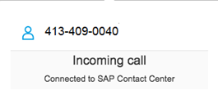
Figure 1: Incoming Call in C4C

In cases when the search is not successful, the agent will conduct a manual search of the customer using a variety of key search identifiers such as service address, meter number, name, etc.

IVR Integration with C4C
Whenever the agent receives a phone call, the telephony client will pass all call attributes (caller’s number, called number, other information collected by IVR) to the Genesys Workspace Desktop. The Genesys Workspace Desktop, which is constantly listening, will take the information and push it to the browser window in which C4C is running using GPlus connector.
From the agent’s perspective, the screen pop appears exactly when the softphone starts ringing. Call features such as hold, hang-up, transfer, etc. are on the Genesys Workspace Desktop client and not in C4C. The agent can start taking notes in C4C while on the call.
CTI Integration
CTI integration with C4C will be handled by integration with a Local Adapter. This requires the local adapter to run on the agent’s desktop. Call handling is in a separate CTI App.

2.9.2 C4C Views
When there is an incoming phone call, the CCC agent is alerted through a screen pop. The screen pop (see figure 2) is displayed regardless of the screen the CCC agent is currently on.

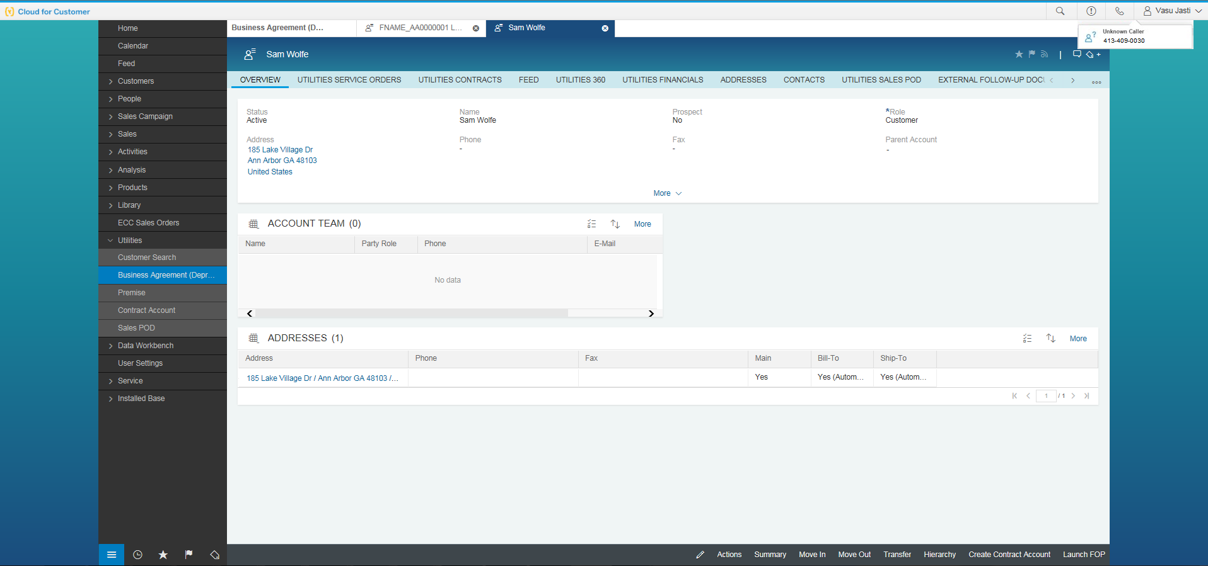
Figure 2: Screen pop in C4C

The screen pop appears when the softphone (Genesys Workspace Desktop) start ringing. Clicking the screen pop brings the CCC agent into the Live Activity Center (see figure 3), where a search is automatically triggered based on the caller’s phone number (ANI number) or an account identifier passed by the IVR.
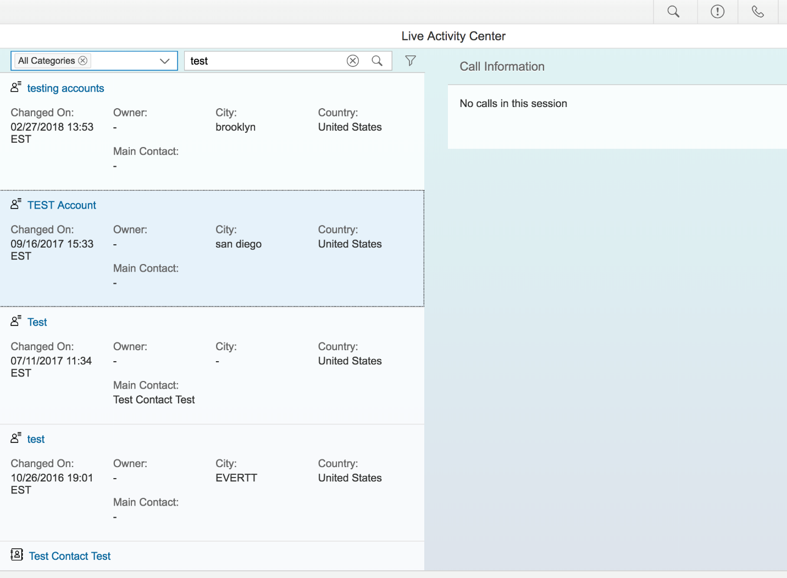
Figure 3: Live Activity Center in C4C

Live Activity Center
Live Activity Center is designed for the CCC agent to handle the call. The Live Activity Center has 3 primary sections:
- The global search: Allows the CCC agent to identify the caller using available information such as customer details and ticket details. Each of the results of the search will contain the Confirm icon to confirm the caller.
- Call information area: Contains caller details, area for entering notes, etc. Every incoming call is logged as a phone Activity. Agent can edit the attributes of the phone Activity in this section.
- Follow-up actions area: Allows the CCC agent to create a new BP (if the caller does not already exisit in SAP) or create a follow-up ticket.

2.9.3 Activity
In C4C, an Activity will be created manually by the agent when a customer’s call is routed to the call center and the agent makes any changes to their account(s).
An Activity is not created for any actions performed by the caller within the IVR. Caller actions in IVR is captured via BP Contact in S4/HANA specified in section 2.1.2.

2.10 Exception Management Requirements
This section outlines a high level description of each BPEM Case or other user workflow items (such as “Tickets” used by Front Office) used to route work requests between business areas. The companion document for this section which outlines the detail of each case is documented in APSE on the Exception Case Template General Document #8.
User Exception Scenario / Description | User Group | Initiated by | Work Distribution
See separate Exception Case document

2.11 Process Risks and Mitigation

Risk Statement | Mitigation
If the C4C agent is allowed to decline an incoming IVR call, then agent will be able to select which calls they are accepting and which calls they are declining. | The risk can be mitigated by suppressing the accept/decline option and maintaining the telephony functionality on the Genesys Workspace Desktop.
If current IVR functionality is not available, live agent call volumes will increase, need for additional resources and potential reduced customer satisfaction | Focus design on most high volume transactions and define acceptable workarounds to minimize operational impacts and reduce risk of negative customer satisfaction
If CTI pop up is not support similar to today (e.g., account and transaction screen) it will require ENAs to manually search for an account on every call resulting in increased AHT and potential risk of repetitive motion injury increase. | Screen pop-up will be displayed based on the Calling phone number details.
If IVR is unable to connect to ISU to retrieve caller account details, the call must be transferred to an ENA which could cause a significant increase in caller hold time and AHT. | This can be managed by planned outage messages.
If IVR is unable to complete transactions with ISU successfully, the call must be transferred to an ENA which could cause a significant increase in caller hold time and AHT. | This can be mitigated by playing appropriate messages to the customer and error handling in the interfaces.

2.12 Key Performance Indicators
The following have been identified as KPI’s at Southern California Edison, along with the means of measuring each KPI and the current measurement statistic for each KPI:
Measured KPI | Description | Measurement Method | Current Statistic

2.12.1 Key Metric Definition
The following have been identified as key metrics at Southern California Edison that require business rule for calculation:
Key Metric | Description | Business Rule | Reference
N/A

3 Controls, Regulatory Rules, and Security

Requirement  ID (from RTM) | “As-Is” Control Requirement | “To Be” Risk Statement | “To-Be” Control Activity” | Control Automation (manual, IT dependent- manual, automated | Relevant technical identifier or RICEFW reference
1606 |  | Automatic Dialing Announcing Devices, Random or Sequential Numbers Generated, (PUC Code 2875.5(a)): Effective July 1, 2002, SCE acceptable error rate for telephone calls made by automatic equipment shall be 3%, measured monthly. The error rate is defined as a call made by automatic telephone equipment and answered by a live person in which (1) the telephone equipment disconnects the call after the called party has answered, or (2) the called party does not receive a response from the calling agent within 2 seconds of the called party’s completed greeting.  Effective July 1, 2003, SCE shall maintain summary records tracking for (1) all predictive dialer calls answered by a live person, and (2) all predictive dialer calls in which either the dialer disconnects the call after the called party has answered, or the called party does not receive a response from the calling agent within 2 seconds of the called party’s completed greeting. The call records in the second category shall include the date and time of each call, and the number called, including area code. Records shall be maintained for a period of at least one year and shall be made available to the Commission upon request. SCE is directed to formulate consumer education messages about telemarketing calls, subject to review and approval by the Commission’s Public Advisor, to be included on at least an annual basis in an informational mailing. [Article 1. Automatic Dialing-Announcing Devices [2871-2876] (Article 1 added by Stats. 1978, Ch. 877.] | In the legacy environment this is being addressed as follows: GRP Report Y/N: No - No - N/A - N/A - N/A - N/A - N/A - N/A

3.1 Security Considerations
- User Roles with access to telephony features within C4C are defined in BPD CIM-CS-17 Front Office.

3.2 Custom Program/Transaction Codes
- N/A

3.3 Custom Table/Transaction Codes
- N/A

3.4 Data Criticality and Cybersecurity Baseline Risks

Specify Data Classification /Special Handling or Regulatory Requirement  What is the classification of Data? Does it trigger any special regulations?  Please select the classification / Sensitivity of the Data. This will help us Assess the Risk associated and remediation measures if any. | <Select all that apply>  ☒ PII - Personal Identifiable Information / Privacy Law  ☐ CEII - Critical Energy Infrastructure Information  ☐ FERC SOC (Standards of Conduct)  ☐ NERC CIP Confidential  ☐ Sarbanes-Oxley (SOX) financial reporting data  ☐ SCE utility data accessible by affiliate companies (CPUC)  ☒ PCI - Payment Card Industry Compliance  ☐ Customer Information Service Request (CISR, CISR-DRP)  ☐ Other _<Please Specify>_  ☒ Internal  ☒ Public  ☒ Confidential
Please identify which business Group/Role will require access to the data and/or solution:  Please select the list of Busines Groups will have access to this Data / Process. This will help us Determine the Impact and Risk Spread. Will ensure efficient Risk mitigation measures. | <Select all that apply>  ☒ SCE Customer, Res./Comm. Customer;  ☒ SCE OU, Business Function Organization Name: CS, T&D, BCD  ☐ Vendor  ☐ External business partner(s) & SaaS providers  ☒ External on-shore contractors  ☐ External off-shore contractors  ☐ SCE Affiliate Company Employees  ☒ SCE Employees, specify if they have Marketing Function responsibilities (e.g., ES&M)  ☐ SCE contract workers  ☐ Regulatory Agencies  ☐ Others _<Please Specify>_
How many of the SCE Customer, Employee, Vendors will use or affected by the Business Process?  To identify the Impact if services are adversely affected. | 10,000+…..
How much Information/data would be processed, received or transmited by the Business Process?  The data volume that will be utilized by this process. Helps us in determining the Impact and criticality | Approximately 40,000 calls per day
Number of business transactions in average?  These are the number of transactions process by the application on average. The number of transactions help in understanding criticality and Impact. | A minimum of 40,000 transaction per day. Most calls result in creation of more than one transaction.
Additional Security Consideration: | Any Cybersecurity impact in addition to SAP system security:  - Internet Facing Web Application? No  - Internet Facing Application Programming Interface? No  - 3rd party Fedrated Authentication & Authorization, Single Sign On? No

Technical Considerations

4.1 RICEF-W Assessment
All of the Forms, Reports, Interfaces, Conversion items, Extensions/Enhancements and Workflows (RICEF-W) that have been identified for this BPD are detailed in the tables below and will represent the totality of all RICEF-W items documented at the time of sign-off of this BPD. Any RICEF-W items that are confirmed via change control after this BPD receives final sign-off, will be managed within Southern California Edison’s APSE environment and not within this document.

Reports
Report Name & Description (List Requirements met by this Report) | Complexity | Reference ID
N/A

Interfaces
Interface Name & Description (List Requirements met by this Interface) | Complexity | Reference ID
The IVR shall enable an authorized caller to get a payment extension on their energy related charges, based on their eligibility  The IVR shall enable an authorized caller to get a payment extension on their deposit charges, based on their eligibility  The IVR shall enable an authorized caller to make payment arrangements for two or three payments (installment plan) on their energy related charges, based on their eligibility. Note: number of payments shall be configurable.  The IVR shall enable an authorized caller to make payment arrangements for two or three payments (installment plan) on their deposit charges, based on their eligibility. Note: number of payments shall be configurable.  The IVR shall enable an authorized caller to request a 4 day payment extension when in final call. Note: The number of days should be configurable.  Ability for customer via IVR, SCE.com (mobile) to establish one-time installment plan (replaces payment extensions), based on business rules  Ability for the customer to via IVR or SCE.com to establish a one-time or multiple-period installment plan for Deposits charges, based on business rules  The IVR shall enable an authorized caller to make payment arrangements on the past due amount on their account (not the entire balance) when requested.  When a payment is pledged via a HEAP agency in IVR, the system shall automatically issue an extension for the account to avoid collections and/or disconnection. | Medium | I-CC-FI-08 - Create Installment Plan via IVR
When a trouble order is created via IVR, the caller shall be able to enroll in outage updates for that outage (voice or text alerts) if they are not already enrolled in proactive outage alerts for the account.  The IVR shall enable an authorized caller to hear the near real-time status of an outage impacting their account (e.g., estimated restoration time, problem, cause, result, and crew status, how many accounts are impacted) by enter account information (e.g., contract number, contract account number, street number). Note: Outage could be repair, maintenance, rotating, emergency or macro outage.  The IVR shall enable an authorized caller to hear outage information based the geographic locations in by zip code including (e.g., estimated restoration time, problem, cause, result, crew status, how many accounts are impacted).  The IVR shall be able route callers to specific agents (based on configurable scenarios), when the IVR has identified the account the caller inquiring is in need of special handling.  The IVR shall enable a caller to hear the near real-time status of an outage (e.g., estimated restoration time, problem, cause, result, crew status, how many accounts are impacted) by entering a unique trouble order number. Note: Outage could be repair, maintenance, rotating, emergency or macro outage.  The IVR shall enable a caller to hear the near real-time status of an outage (e.g., estimated restoration time, problem, cause, result, crew status, how many accounts are impacted) by entering the OAN. Note: Outage could be repair, maintenance, rotating, emergency or macro outage.  The IVR shall be able to provide an authorized caller historical and future dated outage information by entering the trouble order number or OAN (e.g., outage start/end date, cause, etc.). Note: Today it is only provided for Planned/Maintenance Outages  The IVR shall have the ability to know if the power is connected or disconnected and the reason if power is off (e.g., power outage, credit disconnect, meter removed, etc.)  The system shall enable a caller to receive outage update information via the third party IVR when calls are routed to the third party IVR. | Complex | I-CIM-CS-10 - Outage Details
The IVR shall enable an authorized caller to enroll in the Energy Assistance (EAP) programs.  The IVR shall enable an authorized caller to hear the status of their EAP enrollments.  The IVR shall enable an authorized caller to apply for the Energy Savings Assistance Program (Low Income Energy Efficiency)  The IVR shall enable an authorized caller to check the status of their Energy Savings Assistance Program (Low Income Energy Efficiency) application. | Medium | I-CIM-CS-10 - PnP Programs
The IVR shall have the ability for an authorized caller to verify payment was received and processed  The IVR shall have the ability to advise an authorized caller if a payment is pending  The IVR shall have the ability to provide an authorized caller the closing bill amount  The IVR shall have the ability to provide an authorized caller bill amounts, payments and due dates for an account.  The IVR shall have the ability to provide an authorized caller debits and credits on an account (e.g., fees and payments)  The IVR shall have the ability to provide an authorized caller recent payments applied to an account  The IVR shall have the ability to advise an authorized caller if account is in final call status and details (e.g., past due amounts, due dates, disconnect date).  The IVR shall provide a caller the nearest APA location information by zip code. | Medium | I-CIM-CS-10 - Self Service - Billing,Payment/Enquiry hist
The IVR shall enable an authorized caller to enroll in Budget Billing (aka LPP) based in eligibility  The IVR shall enable an authorized caller to unenroll from Budget Billing (aka LPP).  The IVR shall enable an authorized caller to hear their YTD summary details for Budget Billing (aka LPP).  The IVR shall enable an authorized caller to update their Budget Billing amount (aka LPP).  The system shall advise the IVR if the customer is enrolled in Budget Billing (aka LPP) or if enrollment is pending. | Medium | I-CIM-CS-10 - Self Service - Create/Cancel level pay Plan
The IVR shall have the ability to search for a customer by Contract Account number.  The IVR shall have the ability to search for a customer and associated accounts by BP phone number  The IVR shall have the ability to search for a customer by Contract number  The IVR shall have the ability to search for a customer by street number.  The IVR shall have the ability to search for a service location by Installation number (aka Installed Service).  The IVR shall be able to search and retrieve business partner and account information using the BP's phone number.  Ability for SAP to know if customer has already authenticated in IVR, no authentication is required by customer again when transferred to the rep | Complex | I-CIM-CS-13 - User Authentication
The IVR shall enable an authorized caller to hear specifics related to their deposit including amount, historical deposits, refunds, when eligible for a deposit refund.  IVR shall be able to advise the authorized caller the amount needed to reconnect the CCA account (different from bundled accounts).  The IVR shall enable an authorized caller to hear if their account is on inactive collection status and provide the collection agency name and phone number.  The IVR shall have the ability to provide an authorized caller quoted minimum payment to avoid disconnect  The IVR shall have the ability to provide an authorized caller quoted minimum payment to reconnect service | Medium | I-CIM-CS-13 - Account Balance
IVR shall be able to route outage inquiry calls to an alternate tele-vendor when needed, whereby vendor shall enable a caller to perform same outage related functions. "used during high call volume". Enabling/disabling is configurable. | Medium | I-CIM-CS-13 - Alternate Tele Vendor
Ability for the IVR to know if the account is enrolled in CCA.  Ability for the IVR to know if the account is enrolled in DA  Ability for the IVR to know if the account is eligible for CCA. | Medium | I-CIM-CS-13 - CCA/DA Enrollment
The system shall advise the IVR if the account is enrolled in E-Bill/Paperless billing.  The IVR shall enable an authorized caller to enroll an account in E-Bill/Paperless Billing if eligible.  The IVR shall enable an authorized caller to unenroll an account from E-Bill/Paperless Billing.  The IVR shall enable an authorized user to enroll in Online Billing.  The IVR shall enable an authorized user to unenroll in Online Billing. | Medium | I-CIM-CS-13 - E-Bill Enrollment/Un-enroll
The IVR shall be able to communication emergency relief information and shelter information to the caller based on their account location or geographical information (e.g., zip code). | Medium | I-CIM-CS-13 - Emergency Information
The IVR shall enable an authorized caller to opt-out of CCA for an account based on eligibility.  The IVR shall have the ability for an authorized caller to cancel a pending CCA opt-out. | Medium | I-CIM-CS-13 - Opt Out
The IVR shall be able to determine if the account identified has a pending HEAP pledge.  The IVR shall enable a caller to submit a HEAP pledge for an account based on eligibility (pin, agent ANI and agent agency). | Medium | I-CIM-CS-13 - Submit Pledge
The IVR shall enable an authorized caller to recertify for CARE if they are currently on FERA.  The IVR shall enable an authorized caller to unenroll from FERA  The IVR shall enable an authorized caller to check the status of their CARE enrollment.  The IVR shall enable an authorized caller to unenroll from CARE  The IVR shall enable an authorized caller to enroll in CARE if they are eligible.  The IVR shall enable an authorized caller to enter information to determine if they are eligible to enroll in CARE.  The IVR shall enable an authorized caller to recertify for CARE.  The IVR shall enable an authorized caller to check the status of their recertification application for CARE.  The IVR shall enable an authorized caller to apply for FERA when they are not eligible for CARE.  The IVR shall enable an authorized caller to enter information to determine if they are eligible to enroll in FERA when they are not eligible for CARE.  The IVR shall enable an authorized caller to apply for FERA if they are no longer eligible for CARE.  The IVR shall enable an authorized caller to check the status of their FERA enrollment. | Medium | I-PP-02 - Web Service to Enroll/De-enroll in/from CARE & FERA programs
The IVR shall enable an authorized caller to enroll in Direct Pay/Auto Pay if BP is not flagged as Cash Only  The IVR shall enable an authorized user to unenroll from Direct Pay/Auto Pay  The IVR shall enable an authorized caller to update their checking account and routing information for Direct Pay/Auto Pay  The IVR shall have the ability to know if the customer is enrolled in direct pay or is in the enrollment process. | Medium | I-PY-FI-09 - Eligibility and Enroll Customer from SCE.COM/IVR into Direct Pay

Conversion
Conversion Name & Description (List Requirements met by this Conversion) | Complexity | Reference ID
N/A

Extension/Enhancements
Extension Name & Description (List Requirements met by this Extension) | Complexity | Reference ID
The IVR shall enable an authorized caller to enroll in SDP if they are eligible.  The IVR shall enable an authorized caller to unenroll from SDP if they are eligible.  The IVR shall enable an authorized caller to check the status of their SDP enrollment.  The IVR shall enable an authorized caller to hear their current SDP participation settings (cycling % and override/non-override).  The IVR shall enable an authorized caller to change their SDP cycling percentage if eligible.  The IVR shall enable an authorized caller to change their SDP override option if eligible.  The IVR shall be able to know if an account is enrolled in SDP or is pending SDP.  The IVR shall be able to know if there is an SDP device at the account location and the device capabilities.  The IVR shall advise the authorized caller if there is an active SDP event for one of their accounts.  The IVR shall be able to advise the authorized caller when the active SDP event is expected to end for an account. | Medium | E-PP-02 - Enroll/De-enroll in/from SDP Residential & Commercial Programs
The system shall be able to store the APA paper payment receipt number, amount paid and date paid received via IVR.  The system shall be able to store the APA paper payment receipt number, amount paid and date paid received via agent entry in the system.  The IVR shall be able to provide the caller the nearest APA locations to their account. | Medium | E-PY-FI-09 - Store APA details in SAP

Forms
Form Name & Description (List Requirements met by this Form) | Complexity | Reference ID
N/A

Workflows
Workflow Name & Description (List Requirements met by this Workflow) | Complexity | Reference ID
N/A

IDEX Considerations
N/A

Production System Cut-over Considerations
During the production cut-over process, the IVR system will have a down-time period.

4.4 Other Considerations
N/A

Change Management

5.1 Change Impacts
Change Element Short Description | Change Impact Category | Audience Group(s) | Impact | Business Effort
In SAP, users will document the customer contact via an activity/ bp contacts. It is a comprehensive activity history that can be used by all SCE users that interacts with the customer. It will also record contacts from sce.com as well as IVR. The status will automatically be coded as complete for each interaction with the ability to change the status. This provides a full view of the customer's touch points. Frontline agents will need to analyze and review contacts and determine customers' needs. Today an agent documents the contact in a disposition and through notes and it is only available to the CCC and IVR.  Customer Impact: This should enhance customer experience because agents will have access to all activities at their fingertips. | Process,  Culture Shift,  Benefit/Improvement,  Technology,  Decision Making (40) | CS-CSOD-CCC All  CS-CSOD-RSO All  CS-CP&S-All  CS-BCD-All | Medium | Medium
Currently, call center screens will pop on the appropriate screen based on the IVR transaction selection and a completed authentication process. SAP will not be able to provide the full screen pop. If the IVR is able to authenticate the customer, the data will populate in the search screen and the agent will need to click search to complete the request. If properly used, CTI pops can save the agents average handle time and search time of the customer. | Technology, Process (895), Process | CS-CSOD-CCC-Systems/IVR  Ext-Customers-All | High | High
IVR will be able to advise a caller that we are aware the account is currently experiencing an outage once the account has been identified. This can increase IVR utilization and decrease live agent call volume. This is a process improvement.  Customer Impact: Customers will not need to wait for an agent to respond to a call during an outage. Typically there are longer wait times due to the call volume. | Improvement; Process; Technology (1137) | CS-CSOD-CCC-Systems/IVR  Ext-Customers-All | High | High
IVR will be able to advise the caller that we are aware they are in an SDP event once the account has been identified. This is a process improvement.  Customer Impact: Customers will know if they are included in the SDP event without having to wait for an agent. | Improvement; Process; Technology (1138) | CS-CSOD-CCC-Systems/IVR  Ext-Customers-All | High | High
The IVR will require the caller to agree to a Safety Message when submitting payment to be reconnected regardless if the meter is RSS enabled or not. This is a public safety improvement. | Improvement; Process; Regulatory/Legal;Technology (1139) | CS-CSOD-CCC-Systems/IVR  Ext-Customers-All | High | High
With SAP, IVR will automatically create a BPEM case to Specialty Operations to mail brochures/product information to customers. Currently a batch job is created with an email to fulfill the request. The process on how Specialty Operations will receive the request will change. They will need to complete and close the BPEM case once the brochure is mailed to the customer. | Process, Improvement (896) | CS-CSOD-CCC-Systems/IVR;CS-CSOD-CCC-PS | Low | Low
With SAP, IVR will automatically create a BPEM case to OLS to change the customer bill due date upon request. OLS will update the customer bill data in S/4HANA and close the BPEM.  Currently, this process is automated. OLS work volume will slightly increase to complete this workload. | Job Roles (Neutral); Staffing Levels; Process (1140) | CS-CSOD-CCC-Support; CS-CSOD-CCC-Systems/IVR | Medium | Medium
With SAP, IVR will automatically create a BPEM case to OLS to mail a copy of the customer’s bill upon request. OLS will use C4C to location the statement, select it and send a copy to the customer and then and close the BPEM.  OLS work volume will slightly increase to complete this workload. | Job Roles (Neutral); Staffing Levels; Process (1141) | CS-CSOD-CCC-Support; CS-CSOD-CCC-Systems/IVR | Medium | Medium
Customers will not be able to check the status of their rebate application through the IVR. Customers will need to either go through sce.com or through a live agent to receive the status. This may have a slight impact to Energy Efficiency live agent call volume as well as IVR utilization. | Compensation/Performance;Process;Staffing Levels;Technology (1142) | CS-CSOD-CCC-EE;CS-CSOD-CCC-Systems/IVR | Medium | Medium
With SAP, IVR will automatically create a work order for an SDP enrollment or change request. | Process;Improvement (897) | CS-CSOD-CCC-Systems/IVR | Medium | Medium
IVR will send a BPEM to RSO to complete rate changes. Currently the IVR automatically creates a basic work request that is routed to RSO billing for completion. | Process; Improvement (898) | CS-CSOD-CCC-Systems/IVR | Low | Low
IVR will enable a caller to opt-out of TOU or CPP if they are in the defaulting process and SAP will automatically add the OptOut indicator for the Contract. Today, this is done by adding a profile to CSS. | Process; Improvement (900) | CS-CSOD-CCC-Systems/IVR | High | High

Below is a description of each:
Change Element Short Description: Describes the ‘As-Is’ scenario and what is changing.
Change Impact Category: Determined by asking the questions below.
- Staffing Levels - Is the work effort increasing or decreasing (staffing levels), and how (e.g., task automation, new process/tasks)?
- Job Roles - Will the responsibilities, authority, or required skills for a job or job roles change? Will people be reporting to new leaders? Will managers’ responsibilities change?
- Compensation / Performance - Will the changes have such an impact on roles of an individual that merits a change in how they are compensated or how their performance will be evaluated? What behaviors are rewarded and recognized?
- Organization Structure - Is the ownership of the Process or Data changing (think departments, jobs, or roles, not individuals)?
- Decision Making - Will any of the changes impact how decisions are made, by or between, business units / departments? Who makes them, how they determine the criteria for making a change?
- Culture Shift - Will organizational value systems impact the way change happens or be impacted by the change? What are the underlying values of the organization that will directly influence the way change will be accepted and how much work will ultimately be required to ensure successful outcomes for the business?
- Location / Facilities - Will the change impact the physical location where they process is being implemented or require changes to the facilities to enable the process to be effective?
- Process - Any change to the current process (e.g. manual process becomes automatic, or vice versa)? Are there new processes being introduced or an old process being decommissioned? Is there a requirement to change an existing business rule or business policy? Will new business rule or policy needs to be introduced and enforced or complied to?
- Regulatory/ Legal - Are there any legal / regulatory requirements that might be impacted
- Technology - Are other applications impacted (e.g., going away, becoming read-only), or are there new requirements (e.g., new SW / HW, new version)
- Benefit/Improvement - Will there be an improvement or benefit to any of the stakeholders because of this change. (Be sure to include any pain points that are being alleviated)
- Other - Are there emotional implications stemming from any of these changes (think of buy-in issues or fears)
Audience Group(s): These are the affected departments, divisions etc…
Impact: The following were used to determine the impact:

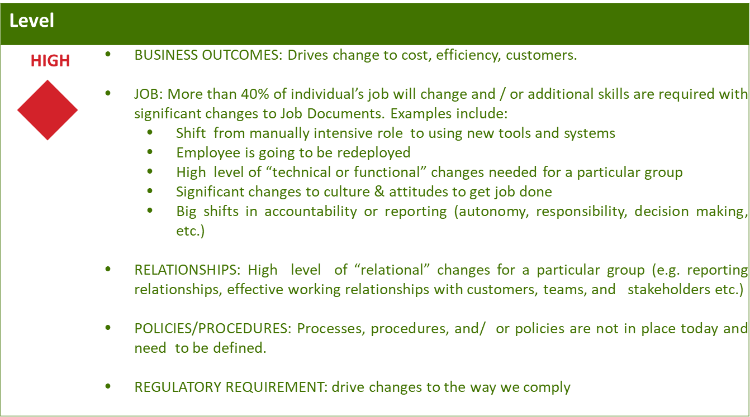
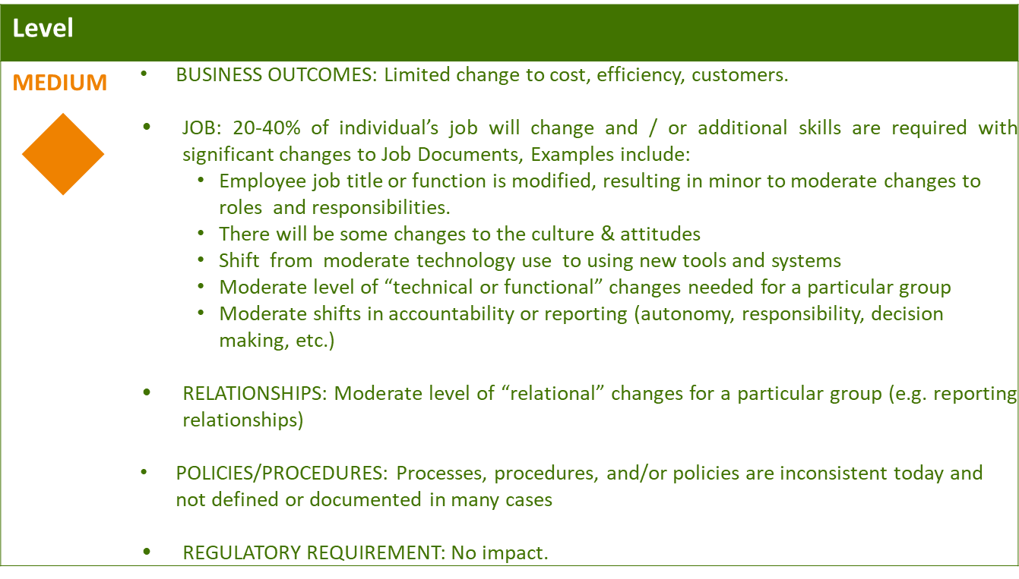
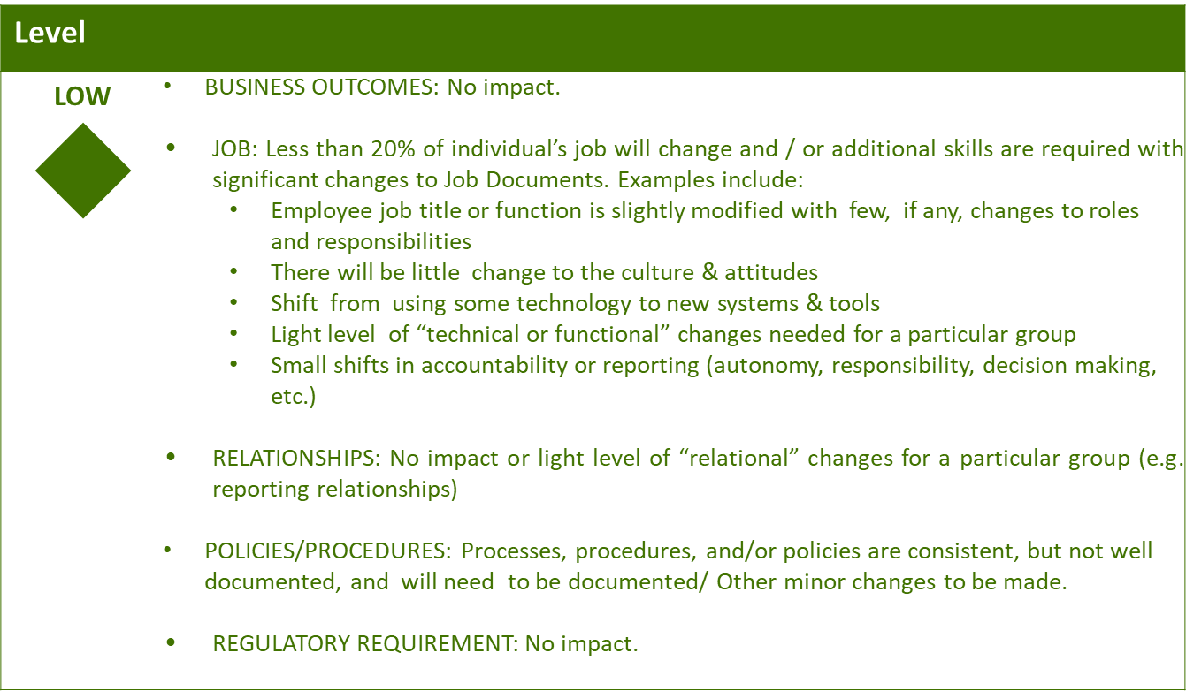

Business Effort: Initial assessment of the impact to the business High, Medium, Low

Requirements

